**First**

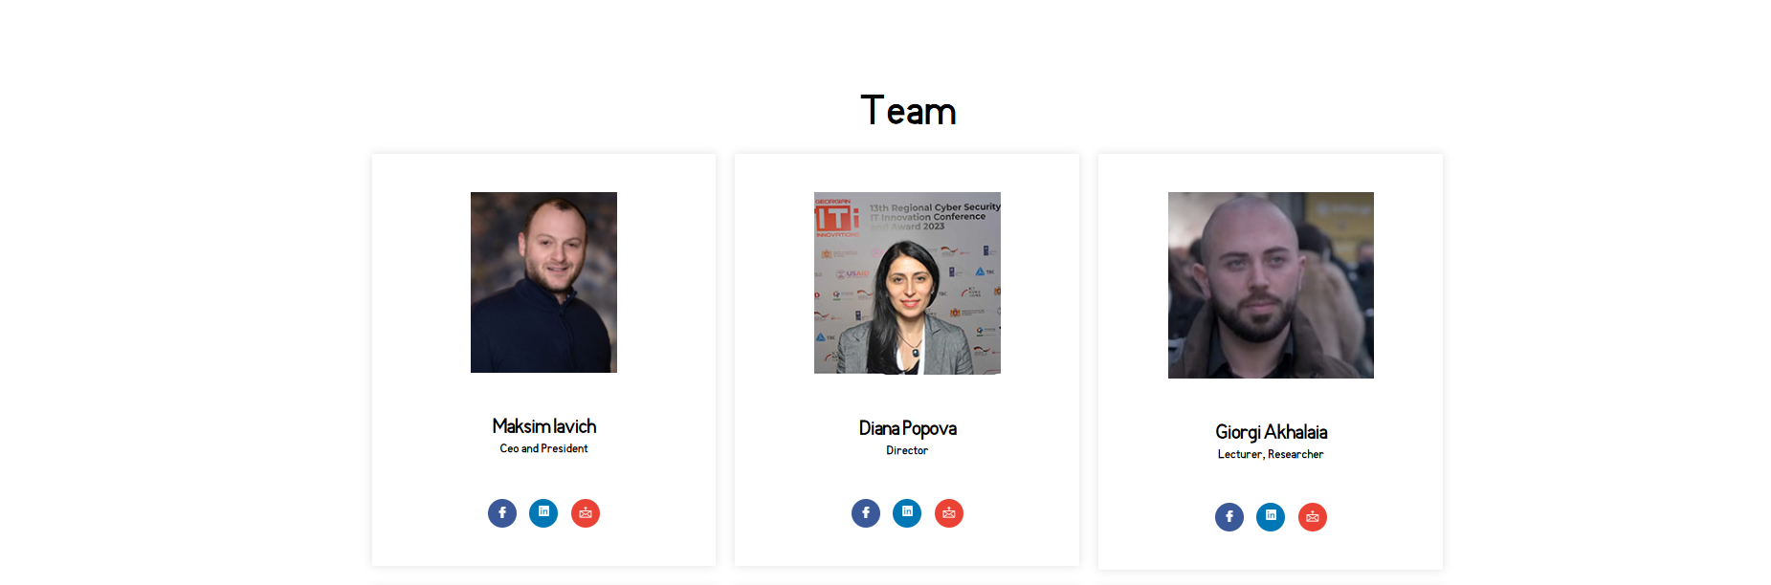

You will need to create the **Team section**. For this, you should:

* Create a separate file where the **team data** will be listed.
* The data should consist of **3 objects**, combined into a single array.
* Use a **Post template component** and pass the data using **props**.
* Information should be passed through **components** using props.
* **Styling must be done with styled-components**.

<https://scsa.ge/en/>

**Second**

Check and correct, explain

1. Data.js

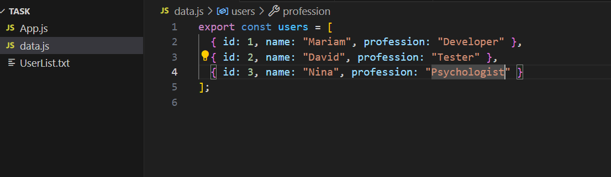

1. UserList.js

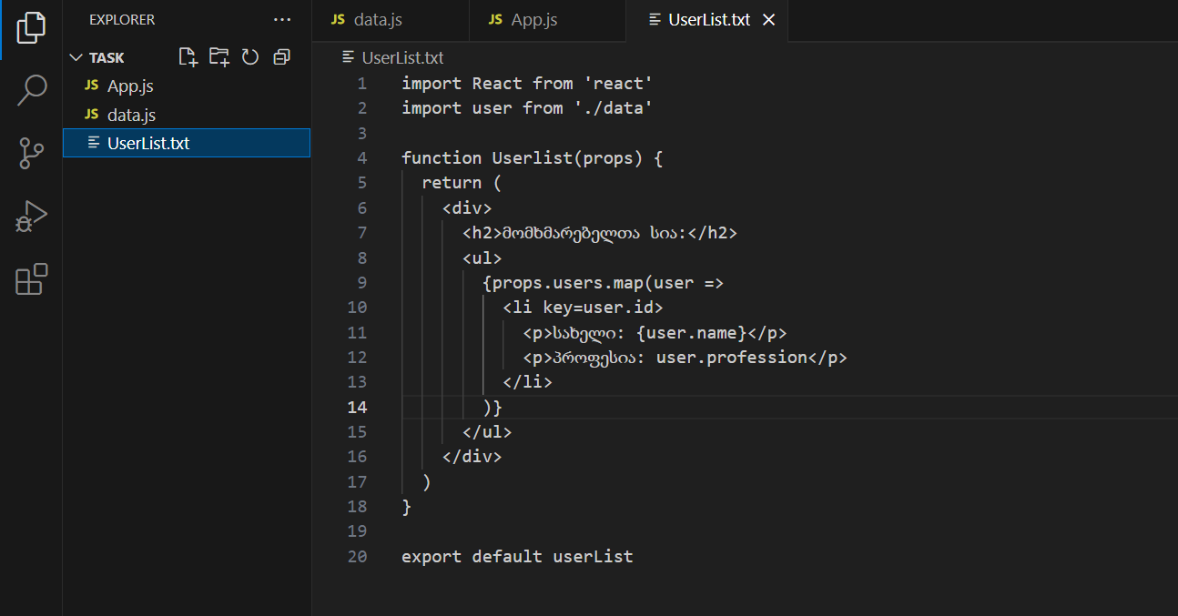

3)App.js

